**EXPERIMENT 4**

**AIM:** Write an ALP to Calculate Factorial of a number

**THEORY:**

**Algorithm :**

1. Input the Number whose factorial is to be find and Store that Number in CX Register (Condition for LOOP Instruction)
2. Insert 0001 in AX(Condition for MUL Instruction) and 0000 in DX
3. Multiply CX with AX until CX become Zero(0) using LOOP Instruction
4. Copy the content of AX to memory location 0600
5. Copy the content of DX to memory location 0601
6. Stop Execution

PROGRAM AND EXECUTION SCREENSHOT

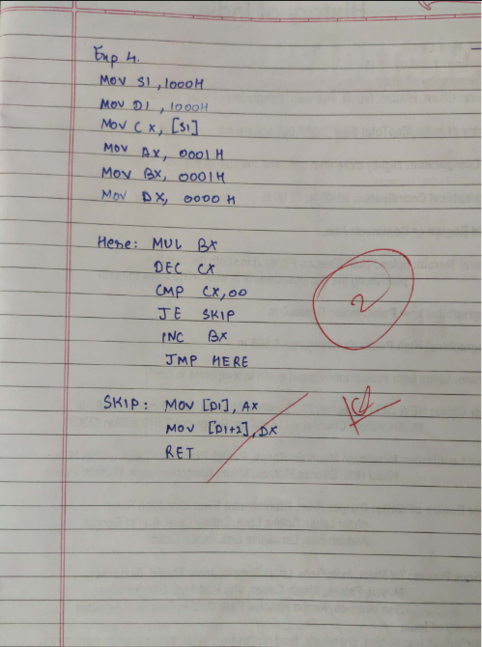

Conclusion: Here we have used multiple Assembly language commands to execute looping

and successfully carried out factorial Program

Name: Abdullah Mohammed Tarique Khan

Roll.no 02

Batch:C1